Achal Gupta

A00258772

tableau features

Data visualization

Table of Contents

Introduction: 2

Dataset: 2

Problem Statement: 2

Features: 3

Cross Database Joins and Data Blending in Tableau 3

Types of Joins in tableau 4

Using R within Tableau 5

Necessary Installation and Setup for R Integration 5

Set Actions in Tableau 6

KIVA Story: 8

World Impact 8

Popularity 9

Exceptional Months 10

Conclusion: 11

References: 11

# Introduction:

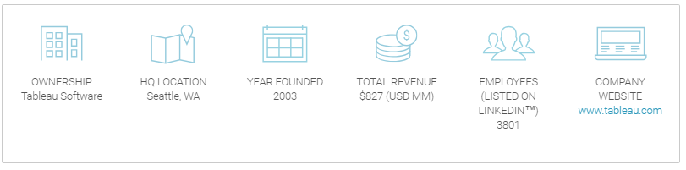

Tableau is a visualization software that helps people transform data into actionable insights. Tableau is the market leader in visualization tools with its easy to use features and extensive data connectivity and ability to perform advance analysis using R and Python directly from the tool.

# Dataset:

KIVA (KIVA.org, 2019) is a nonprofit organization funded by people, founded in 2005 headquartered in San Francisco. What makes KIVA unique is that it asks lenders to fund a loan instead of a charity. According to KIVA there are more than 1.7 billion people around the world who does not have access to a bank account and are unable to access financial aids. KIVA 's mission is to expand financial access to help such underserved communities. Through Kiva's work, students can pay for tuition, women can start businesses, farmers are able to invest in equipment and families can afford needed emergency care.

Data set available at Kaggle.com is a snapshot of KIVA's database containing loan information for over two years (Kaggle, 2019).

<https://www.kaggle.com/kiva/data-science-for-good-kiva-crowdfunding>

# Problem Statement:

Success of an organization is measured from its impact on the society. Using tableau KIVAs impact around the world can be visualized. Moreover, it is important to gather insight on which countries are receiving most of the aids and on which sectors most of the loans are provided. This information can help in gathering information about local needs of the people of specific countries.

# Features:

Tableau is a feature rich visualization tool alongside being user friendly. Below listed are three features of tableau that makes it the market leader.

## Cross Database Joins and Data Blending in Tableau

Cross Database joins and Data blending feature of tableau allow users to integrate multiple types of data sources into a central data source. Thus, allowing users to analyse data from various aspects. Organizations generally have different data in different systems. For example, financial data can reside in a SQL Server database while product data in Amazon Redshift. The data can be present in different environments, but meaningful insights can be gathered only when all the data is analyzed together. Cross Database joins helps achieving such a goal of creating an integrated data source (Tableau, 2019).

In the KIVA crowdfunding example three different data sources are used. First is a Text File (Csv) which contains information about various loans sponsored via KIVA and second is a Microsoft Excel file containing data about Multidimensional Poverty Index for various regions of the world. Third is again CSV file containing Theme information of the loan.

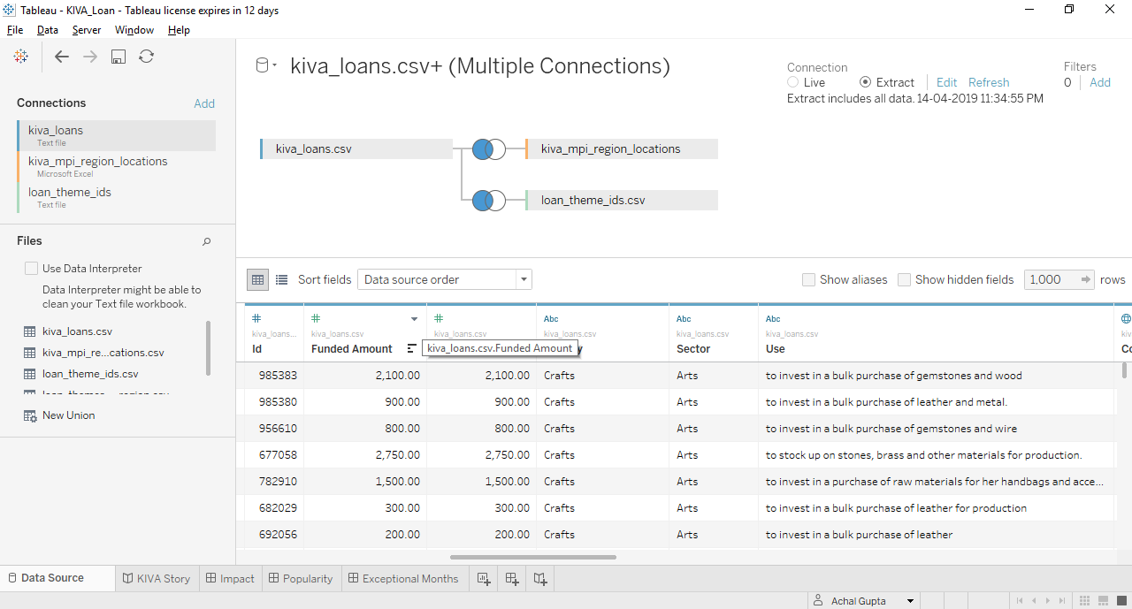

### Types of Joins in tableau

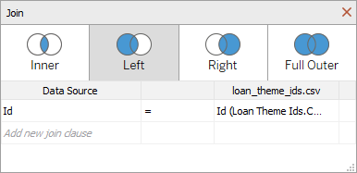

#### Inner Joins

An inner join returns only the rows that exist in both the data sources and have the same key field. In KIVA scenario if Inner Join is used only the loans of countries having poverty index will be available for the analysis.

#### Left Joins

A left join will return all the rows from the left table and brings the corresponding data from the right table. The non-matching rows in right table will be returned with all NULL values. In KIVA crowdfunding scenario a left join is used to gather poverty index wherever available for the countries of loans sponsored.

#### Right Joins

A right join is just an opposite of left join and will return all the rows in right table with NULL values for the non-matching rows.

#### Full Outer Joins

An outer join brings in all names listed in all tables and fills in nulls wherever there isn’t information for a given column for that row.

## Using R within Tableau

R is a free and open source statistical language. It is well known for its data manipulation capabilities and advance data analysis including predictive and prescriptive analysis. Integrating tableau with R allows users to utilize the unparalleled power of R in Data Analysis. Tableau’s R integration is intended for users who are familiar with R and know how to write the scripts and functions required and have access to R server.

Using R within Tableau is a straightforward process. Simply create a calculated field that calls R and contains the R script. Tableau will pass the script and data to R where the computation takes place. The results are returned to Tableau and can be visualized just like any other calculated field. One of the benefits of R is that there is a huge community of users who publish pre-built packages of functions, data, and code.

### Necessary Installation and Setup for R Integration

1. R must be installed on the local system
2. RServe needs to be installed and initiated within R.
3. Tableau Desktop or Server is required, this feature is not available in Tableau Public.
4. Finally, a connection needs to be setup between Tableau and R.

(Tableau, 2019)

In KIVA crowdfunding dataset analysis is done using R to analyse exceptional months. That’s is for a specific country sum of loan amount is captured monthly and months having unusually high or low amounts are highlighted. Thus, the impact of any significant event like a charity event or a promotional event during the month can be analyzed using combined power of R and Tableau.

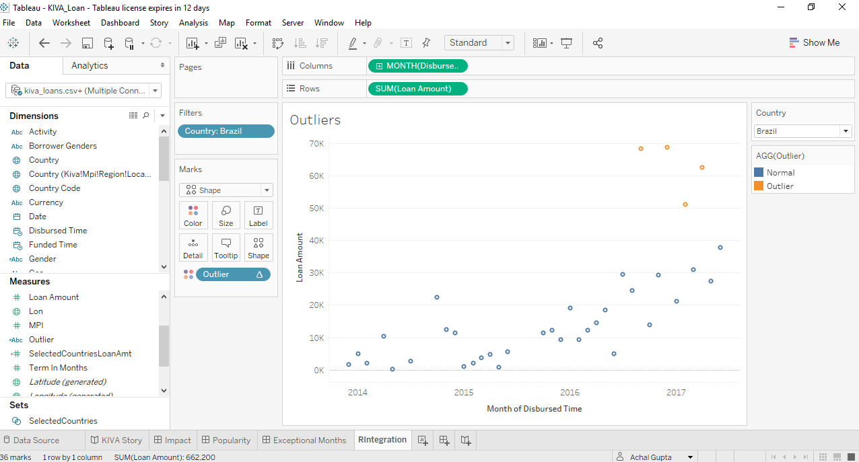

## Set Actions in Tableau

Set actions take an existing set and update its value based on the user's action directly on the visualization.

Set Actions like parameters allow users to control the aspects of analysis. However, there are certain limitations in parameter that Set Actions avoid.

* Sets can be created conditionally or explicitly
* They can contain multiple marks
* And more powerfully provide ability to update sets by selecting from a viz rather than selecting values from a parameter control outside the flow of the visualization.

There are often scenarios in a visualization colour palates where extreme or larger values for certain data points can make the nuances of differences between non-extreme values lost. Set Actions helps in visualizing such scenarios as the values of sets along with range of colour palate is updated using the Set Actions (Tableau, 2019).

In KIVA dataset a map is created displaying the variation of sum of loan amount across various countries.

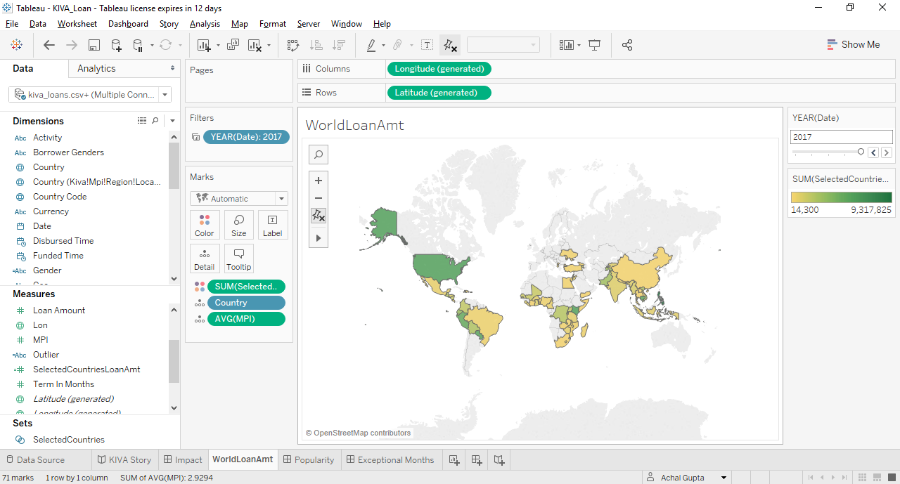

There are lots of areas where for example southern portion of Africa where it’s difficult to understand the variation of loan amount from the colour scheme from the default view. However, when the area is selected using a lasso tool in the visualization the Set Action helps visualize the difference in a much efficient manner.

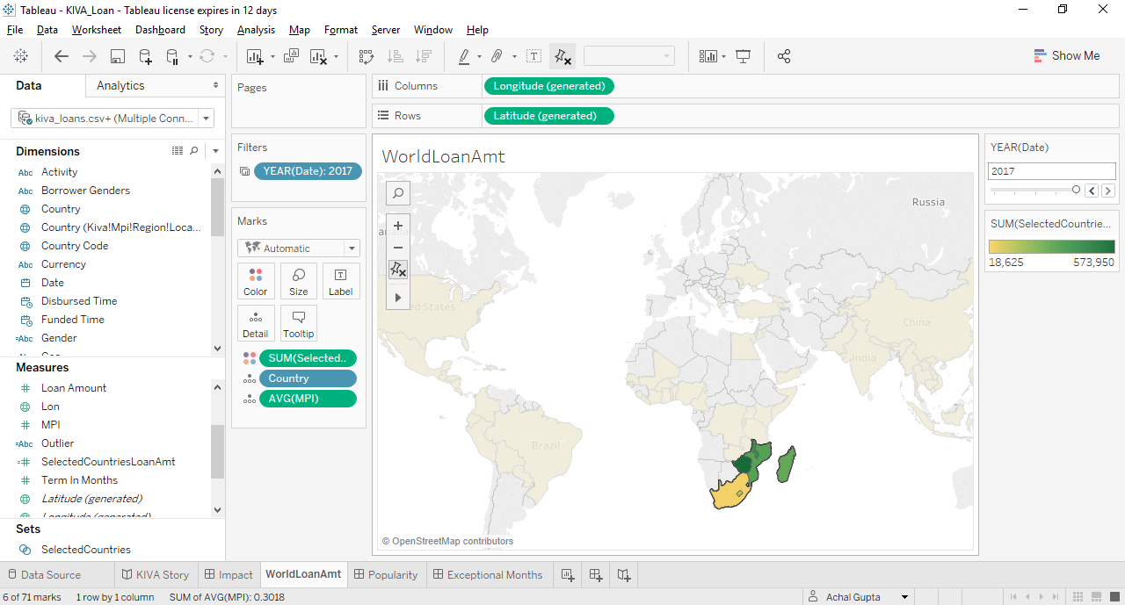

# KIVA Story:

## World Impact

In 2017 KIVA deployed 90 Million USD from more than 18 million lenders to provide over 1 Million loans to people belonging to 71 different countries. More than 5000 loans were sponsored for education and over 33000 loans were sponsored to farmers. Thus, KIVA was successful in creating a large-scale impact over the world over various sectors.

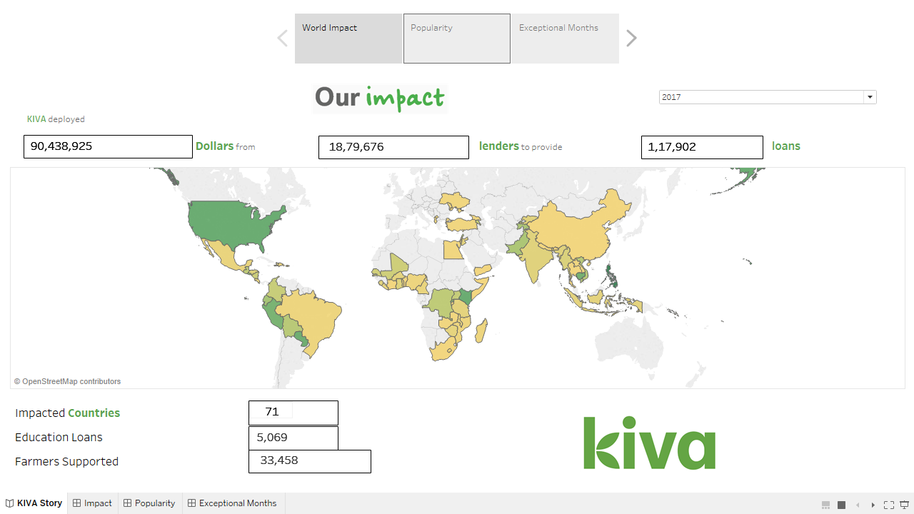

## Popularity

Philippines is the most funded country with Retail as the most funded sector and General Store as the most funded Activity. Thus, people in Philippines are interested in developing their Retail sector and more focus should be made on providing appropriate opportunities.

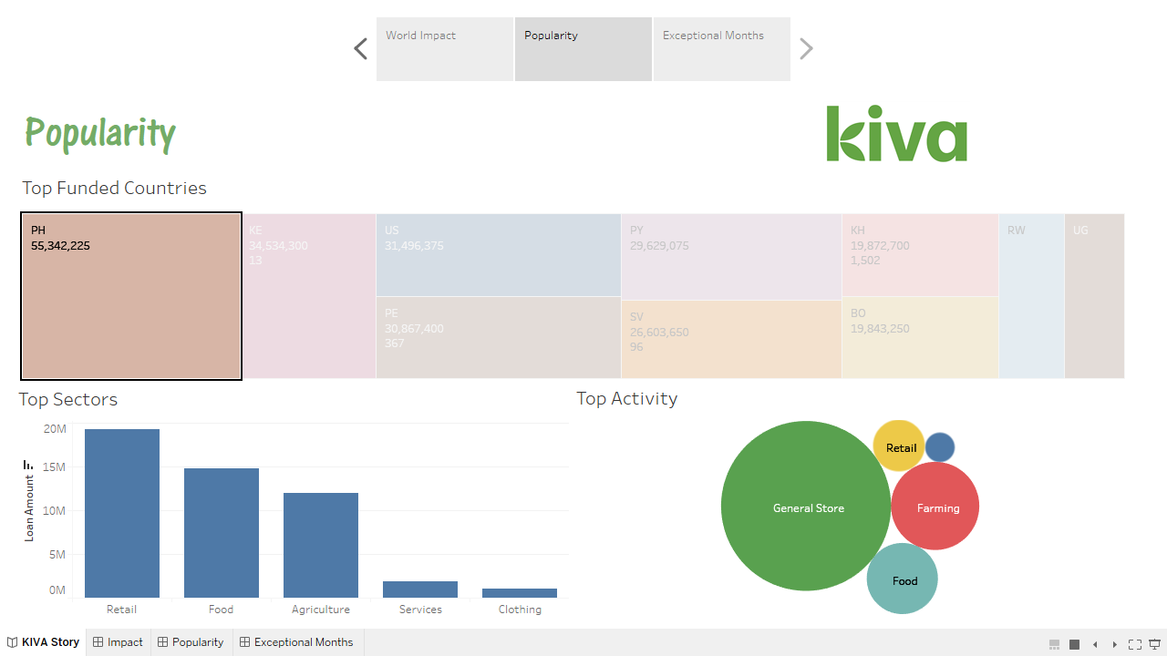

In comparison a developed Country like United States most of the loans are sponsored at Food and Services sectors to increase Food productivity sales. Thus, focus is on improving food quality and optimizing the process to gain more profits.

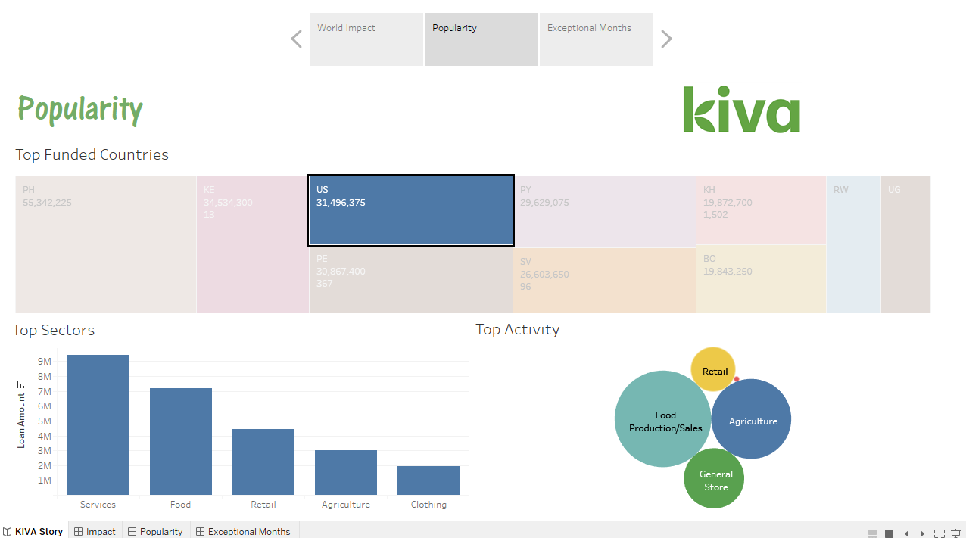

## Exceptional Months

For Brazil, there were four instances when there was exceptionally high amount of loan disbursed by the lenders. Thus, an impact of any significant event during those months can be measured and more such events are encouraged.

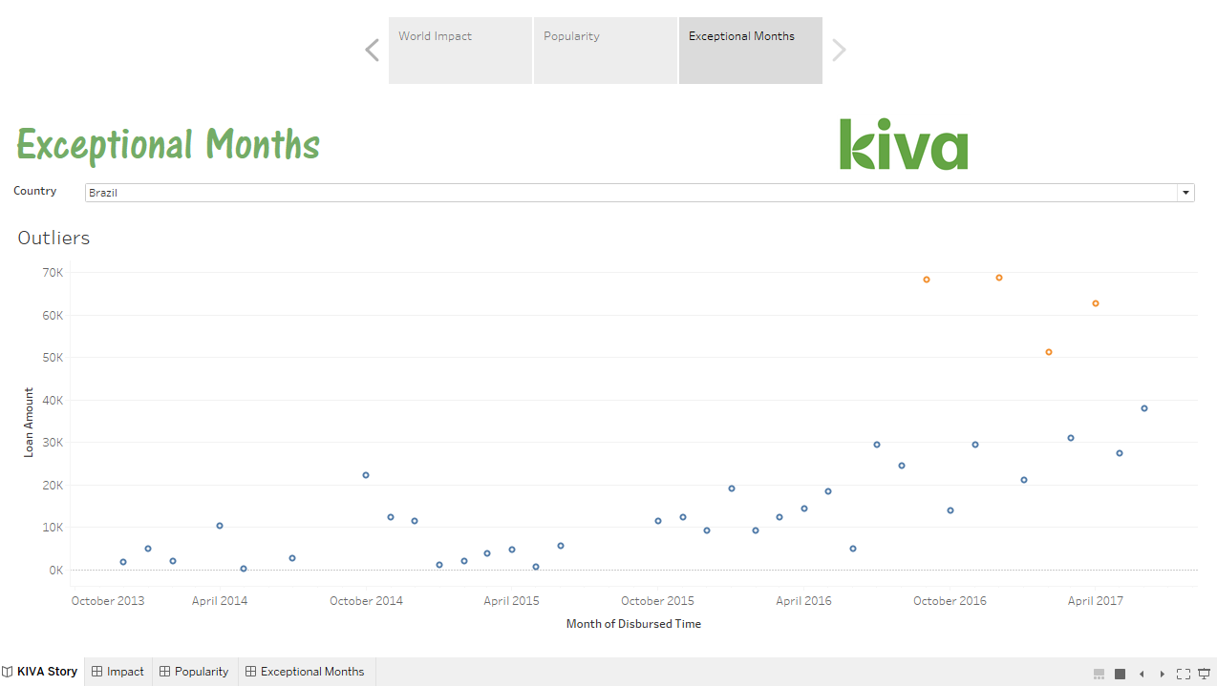

While for Egypt there were no such instances.

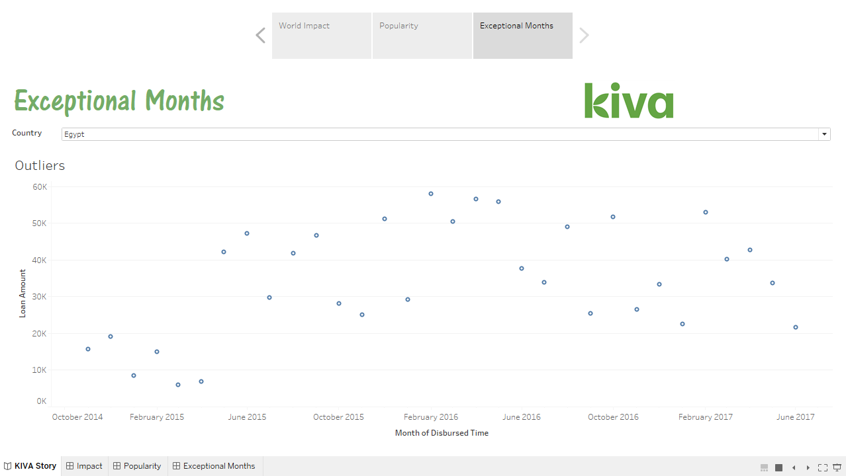

# Conclusion:

Tableau offers a wide range of easy to use features along with many more advanced features required for creating User stories and Dashboards. Tableau can be used to make quick ad-hoc reports and advanced yearly impact stories for the promoters. The adaptive capability of Tableau and an existence if huge community makes tableau the leader in Data Visualization universe. Ability to interact directly with programming languages like R and Python transforms Tableau from just an Visualization tool to a complete Data Analytics tools that can carry out advanced statistical analysis to predictive modelling.

# References:

Kaggle. (2019). *Data Science for Good: Kiva Crowdfunding*. Retrieved from /www.kaggle.com: https://www.kaggle.com/kiva/data-science-for-good-kiva-crowdfunding

KIVA.org. (2019). *About Us*. Retrieved from https://www.kiva.org: https://www.kiva.org/about

Tableau. (2019). *Cross Database Joins*. Retrieved from https://www.tableau.com/: https://www.tableau.com/learn/tutorials/on-demand/cross-database-joins?product=tableau_desktop%2Btableau_prep&version=tableau_desktop_2019_1%2Btableau_prep_2019_1_2&topic=connecting_data

Tableau. (2019). *R Integration*. Retrieved from www.tableau.com: https://www.tableau.com/learn/tutorials/on-demand/r-integration

Tableau. (2019). *Set Actions*. Retrieved from www.tableau.com: https://www.tableau.com/learn/tutorials/on-demand/set-actions?product=tableau_desktop&version=tableau_desktop_2019_1&topic=visual_analytics